BPA2 4D Web Viewer
Evaluation & Requirements

Prepared by
Sebastian Good

December 16, 2013

DRAFT WITH FEEDBACK FROM RIJSWIJK TEAM

Summary
The BPA2 web platform will be used to deploy the NGBA research program, targeting advances in basin evaluation and modeling, primarily through upgrades to the Cauldron simulator. We plan to enable advanced 3D visualization of basin models and other subsurface data elements through a web browser. This document outlines the basic motivations, requirements, and evaluation plans for this effort. Because the change in basin geometry over geologic time is such an unusual requirement in the subsurface world, we call the capability “4D Rendering” to distinguish it from classic 3D rendering in reservoir simulation or seismic interpretation jobs.
We propose a project in 3 stages
- Toolkit Evaluation & De-Risking. Rendering complex scenes on the web is still relatively novel technology, and we must be sure we can provide better performance for real Cauldron meshes than existing solutions like the Petrel Basin Modeling Plugin. We propose evaluating OpenInventor MeshViz to determine whether mesh visualization executes fast enough on real Cauldron data. Only if this evaluation fails do we open the door to other packages.
- Basic cauldron output visualization. As part of NGBA development, build basic 3D visualization functionality to view Cauldron meshes, cross-sections and surfaces through time.
- As-needed improvements for other workflows. Over time, additional functionality such as seismic cross-sections and well-paths will be added. This document includes a list of the relevant data types, but it does not lay out construction details.
This document describes the basic requirements of 4D visualization, and concludes with a project plan for item 1.
We believe the evaluation & de-risking is a ~2 month project for one individual with C++ experience. The end result should be some confidence that the library is adequate for use, as well as code kernels that can visualize Cauldron meshes.

Server Rendering, Client Viewing
A large Cauldron run produces on the order of 10GB to 1TB+ of data. The simulation runs in an HPC cluster and leaves its data behind on disks at the data center. Even if we consider that most basin modelers look at a fraction of the properties produced, this fraction comes to many megabytes or gigabytes of data, too much to quickly transfer over a WAN connection to a client machine. Users of the Petrel Basin Modeling plugin experience poor performance in part because of this basic bandwidth issue.
A large single mesh is on the order of 20 million cells, resulting in approximately 80MB of data to view a property in its entirety. Guidance from Olivier Meuric points to wanting to support 750 million cell model in the next 5 years. This data can be lightly compressed, or depopulated, and some meshes are smaller, but it is still quite large compared to client bandwidth. In a typical Shell deployment, we can expect only a few megabytes per second, meaning it can take a minute to look at a property! Contrast this to bandwidths available from data center connections (from 100-1000MB/s, depending on what is used) where we could load a property in less than a second!
Scenario | Bandwidth (MB/s) | Latency (ms) | Notes
HPC (Lustre to IB) | 500-1500 | 2-10ms | Typically requires custom coding to IB verbs
HPC (Lustre to 10GigE) | 500-900 | 2-10m | On carefully tuned hardware and software!
Data Center / Developer Virtual Machine | 100+ | <1 | Users can’t sit in your data center without parkas
Same Building | 100 | 5 | Unlikely deployment scenario
Metro-area network to corporate data center | 10 | 10 | Likely only at very large business
US Cloud provider to Business-class connection | 1 | 50 | e.g. at mid-size business
US Internet (average home desktop) | 0.5 | 50
NYC-London, Corporate Intranet | 0.5-10 | 75
US Wireless (3G) | 0.4 | 100
London-Hong Kong, Internet | 0.5-10 | 300

Therefore the 4D viewer should render the entire relevant 3D scene within the data center, where it has high bandwidth connections -- 10GigE, or even InfiniBand. Any solution must therefore contain a mechanism for encoding the rendering into a compressed video stream suitable for low-latency rendering in a client browser, transmitting it to the browser, and then decoding it in the browser.
Work on the CDIS project has shown that video up to 2xHD (e.g. 2560x1440) can be broadcast effectively over even cable-modem-quality connections at reasonably interactive frame rates, e.g. 10 frames per second. Crossing the Atlantic adds a performance penalty requiring smaller screens and slightly less smooth movement, but the system is still usable. This is preferable to waiting multiple minutes for data to load up for client-side rendering.
Taking the above into account, the logical architecture of these components is shown below.
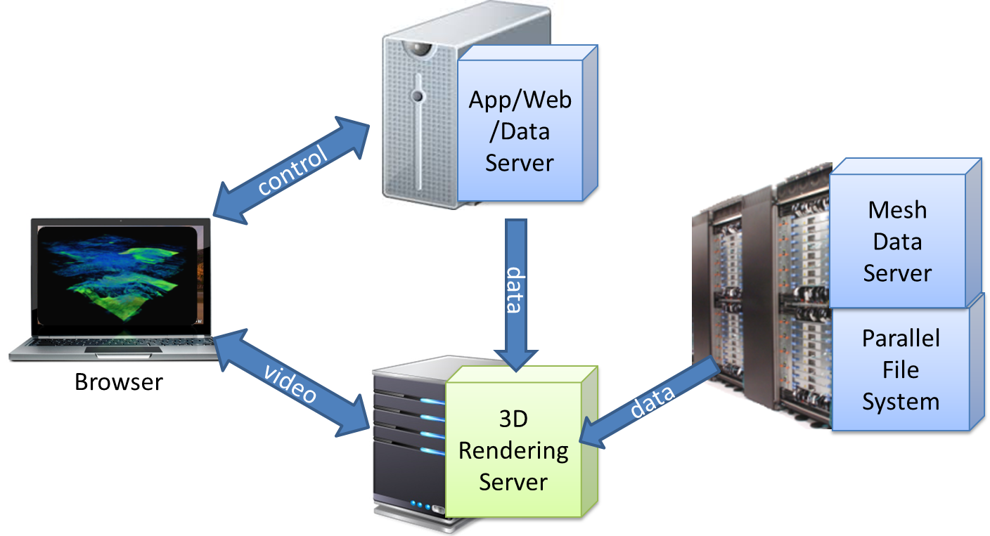

Client (Browser) Requirements
These requirements are taken from the CDIS project, which uses a similar technique. These requirements are mostly satisfied by using a Flash video player, h.264 encoding, and a real-time RTMP server. Other techniques are certainly possible.

Must have
- Support current version of Google Chrome on Windows
- Hardware decoding of video stream if required video card is available
- Honor HTML layering rules (HTML elements can be placed beneath or on top of video. See flash wmode=opaque: http://helpx.adobe.com/flash/kb/flash-object-embed-tag-attributes.html#main_Using_Window_Mode__wmode__values_)
- Plays nice with browser hardware accelerated compositing (for example, in Chrome, make it work like the <video> tags and avoid roundtripping the decoded frames from gpu memory -> system memory -> gpu memory for compositing) (http://www.chromium.org/developers/design-documents/gpu-accelerated-compositing-in-chrome)
- Allow web page to size and position the player using normal css stylings.
- Allow the player to be resized dynamically like any other html element (e.g. if the css width changes, then the player should honor the new width).
- Allow the web page to specify how the video should be rendered when the player size != the video resolution (scale to fit, scale to fit maintaining aspect ratio with borders to keep the image centered, view actual size (do not scale))
- Either allow the web page to specify the color of the background when the video does not completely fill the player canvas, or make the canvas outside the video area transparent so the underlying html shows through. Whichever makes more sense from a performance point of view.
- JavaScript event when the status of the video connection changes (connected, disconnected)
- Expose JavaScript API that allows JavaScript host to determine if hardware decoding is possible (e.g. way for host to determine if hardware requirements are met for hardware decoding).
- JavaScript event when the incoming video resolution changes
- No buffering. As real-time as we can get.
- Ability to run the player without it drawing any UI playback controls (if it even has any).
- Ability to have more than one instance of the player in the web page at the same time, most likely rendering different video streams.
- Support dynamically adding/removing instances of the player.
- Support for up to 4k screens
- video stream is transmitted over an encrypted connection, e.g. TLS.

Nice to have
- Support current version of Firefox on Windows
- Support IE11 on Windows
- JavaScript event when a frame has been rendered (if frames are uniquely identified, then event should include the frame id).
- Uniquely identify frames on the server and client (so JavaScript client can synchronize actions with the server based on when the server encodes a frame and when the player decodes and renders that same frame).
- Unique frame ids should comparable (so we can easily tell which is the newer of a set of frame ids). Just using something like an incrementing integer as the frame id seems perfectly reasonable.

Server Encoding
The solution must have the capability to encode still video frames up to 2560x1440 using h.264 encoding, preferably in hardware, and transmit to the client described above over an appropriate real-time protocol such as RTMP or WebSockets/RTC. We must be able to specify codec parameters.

Deployment implications
BPA is currently deployed on TLS server and HPC clusters in data centers in Houston, Amsterdam and Oman. To manage rendering on the server-side, we will need to deploy to servers with graphics cards (GPUs). These are available in limited quantity and will have to be procured as part of this solution.
Jeff Jackson owns the HPC deployment plan and will be instrumental to getting access to GPU-enabled machines in Houston & Amsterdam. Work with PDO will have to go through different channels.
The evaluation needs to determine how many graphics cards each end-user will need to render typical and large property grids.
We will need to estimate the number of concurrent 3D visualization users to size the number of video cards we need to be able to reserve. nVidia virtualization technology can be investigated to amortize the cost. (http://www.nvidia.com/object/dedicated-gpus.html), but this is a low priority.
To serve the data required by the visualization server will require a dedicated process to read data from the relevant sources (primarily HDF5 files for Cauldron meshes), serving the purpose of the basin modeling service in the current BPA → Petrel basin modeling plugin. For latency and simplicity, this process should be on the same machine as the rendering server where possible, even though we draw it as logically separate on our architecture diagram.
BPA web log data suggest that 98% of the time, Houston has 8 or fewer concurrent Cauldron users, and Amsterdam has 6 or fewer. The maximum seen was 14. This suggests a relatively small number of 4D visualization servers, perhaps 4 with 3 graphics cards each, can service our workload.
We will assume that each concurrent user will have their own rendering server instance, i.e. a process that has access to a graphics card for visualization, and their own data access instance, reading HDF files. It is likely we can host multiple services on a single physical machine since typical server-room class rendering machines have 12+ cores and 2-3 graphics cards.
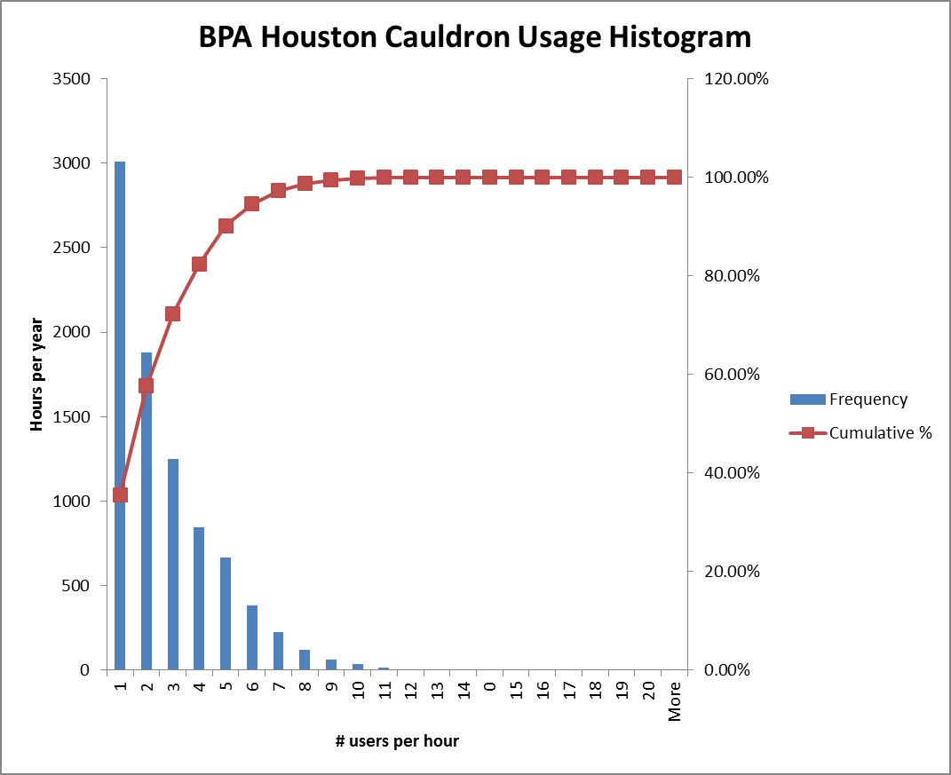

The logging system in the Petrel plugin is not adequate to produce the histogram above, so we cannot add any data to this analysis. We must assume that actual concurrent usage is slightly higher, as it’s possible for the Petrel viewer to be visualizing data without contacting BPA.

Finite Element Mesh
The most complex item to visualize is the finite element mesh which holds the inputs and outputs of the Cauldron simulation. This section of the document recapitulates the excellent summary of the mesh from [Ramshorn 2009], with some of the reference tables elided for clarity, and with some additional verbiage to describe aspired state.

The Cauldron Computational Grid – Present Day
The Cauldron basin simulator conceptually uses a 3D grid to represent subsurface structure and material properties (Figure 1). This is called the Cauldron computational grid and is a part of the basin simulation model.
Grid vertices are regularly spaced in x and y, and have arbitrary spacing in z. As a consequence, the hexahedral grid cells can be allowed to degenerate (vertically connected corner points are allowed to have the same coordinate) in order to represent discontinuities such as pinch-outs, salt bodies, areas of no deposition, and erosion in the 3D grid.
Note: NGBA is considering local grid refinements, which are likely to manifest only as internal simulator details to enhance numerical precision or stability. However we should ensure the 4D viewer can handle finite element meshes with more arbitrary geometries than simple regularly spaced X & Y cells to anticipate the introduction of other refinement schemes.
Thus, the topology of the subsurface structure is represented partially through connectivity of the 3D base space grid, partially through coincident vertices. In Figure 1 to Error: Reference source not found this is expressed through the solid lines in the base space grids and the circles around some of the vertices that describe the shapes of the surfaces forming part of the subsurface structure.

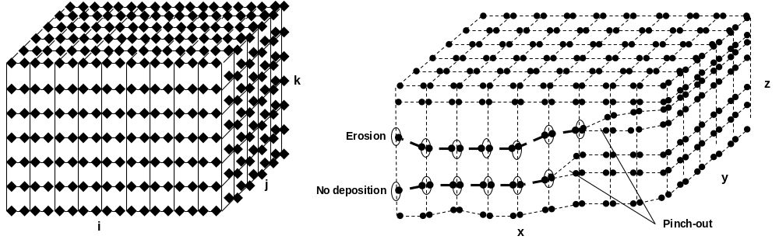
Figure 1 Cauldron computational grid representing subsurface structure. Left: i,j,k base space grid representing topology. Base space grid nodes are depicted as diamonds. Right: vertices (depicted as filled circles) regularly spaced in x,y and arbitrarily in z representing the computational grid’s geometry. The different types of discontinuity shown on the right can be identified as described in .
Cauldron conceptually stores physical properties either for the corner positions of its computational grid cells (nodal variables) (Figure 2 left), for the grid cell center positions (also nodal variables) (Figure 2 center) or for the grid cell volume (zonal variables) (Figure 2 right). Examples here are given for the 3D case; the 2D and 1D cases are analogous. Note that internally Cauldron may use additional storage schemes but they map to the three conceptual schemes. It is the conceptual schemes that need to be visible externally.
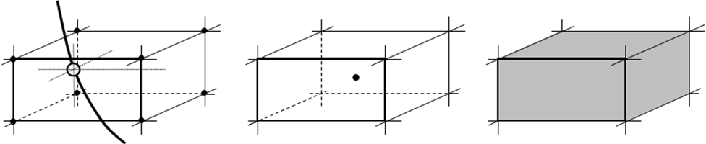
Figure 2 Cells and corner points
During simulation, most properties are treated as continuous in space and time, interpolating values where required. Some variables may be discontinuous (Error: Reference source not found and Error: Reference source not found), for example the porosities of two adjacent layers of sand and clay. For variables stored at grid cell corners, Cauldron represents discontinuities by storing two values for the same variable; one value is valid for the region “above” (in time) the point, the other for “below”. These variables are called “oriented” as they assume different values depending on from which side they are evaluated. Using the correct interpolation function and support is important at and near discontinuities.
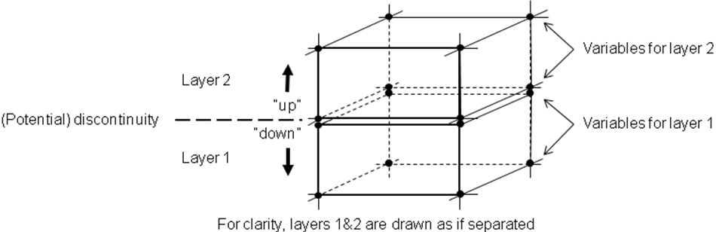
Figure 3 Representation of discontinuities in Cauldron simulation grid

The Cauldron computational grid – development through time
In addition to the present-day state of the subsurface structure, Cauldron also must represent its change through geological time. This is in contrast to reservoir simulators where properties change through time but the subsurface structure does not.
As the modeled basin evolves, the geometry of the subsurface structure changes through formations added by deposition, through erosion, through subsidence, and through other processes. The representations of deposition and erosion in the Cauldron computational grid are depicted in the series of time steps in Figure 4. As the subsurface structure develops through time, the base space grid grows in k. Note that only the lateral connectivity and the vertical sequence of horizons is represented in the base space grid; to identify discontinuities, the values of actual vertex coordinates have to be evaluated.
T₀ represents the base surface of a modeled basin. From time T₀ to time T₁ there is deposition everywhere, from T₁ to T₂ only on the right of modeled space, and from T₂ to T₃ again everywhere. As a consequence, there is a discontinuity where horizon T₂ has not been formed, indicated by the fat dashed line in Figure 4a. This type of discontinuity can be recognized as the area where vertices of horizons T₁ and T₂ have identical coordinates.
From time T₃ to time T₄ there is again deposition on the right of the modeled area but erosion everywhere else. A discontinuity is created in areas where the formation under horizon T₃ has been eroded, depicted by the upper fat dashed line in Figure 4b. This type of discontinuity can be recognized as the area where vertices of horizons T₃ and T₄ have identical coordinates and their positions at time T=4 are different (deeper) from time T=3.
From T₄ to T₆ there is again deposition everywhere in the modeled region (Figure 4c).

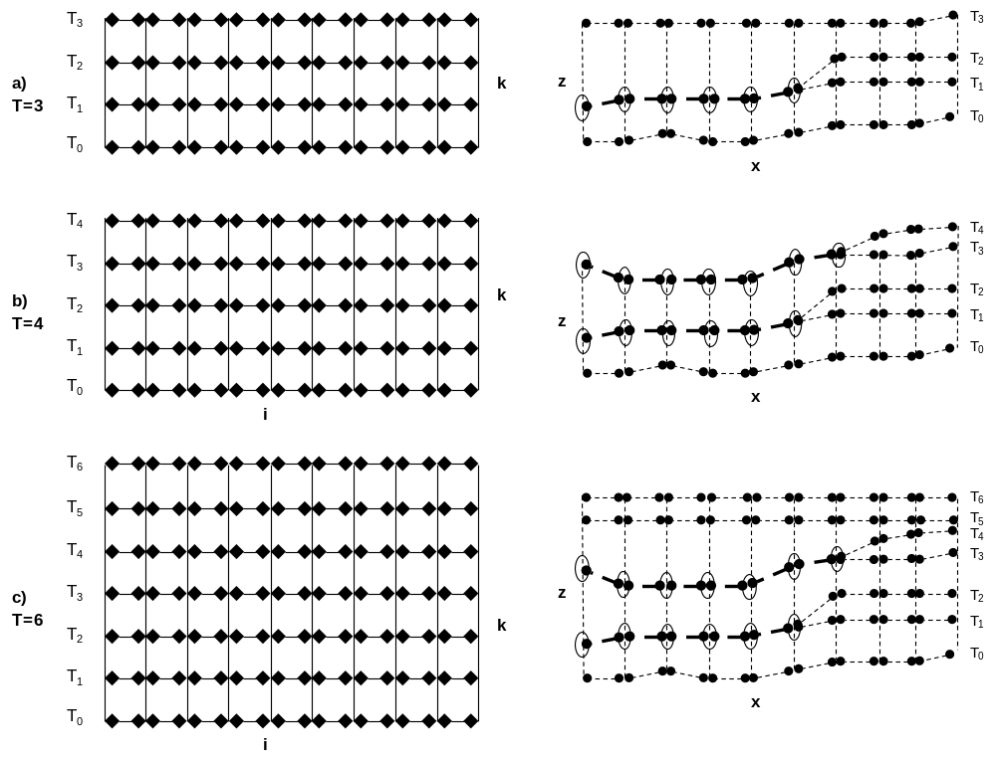
Figure 4 Cross section of Cauldron computational grid for nodal variables at three different time steps. Left: base space i-k plane with nodes (diamonds); right: x-z plane with vertices representing the computational grid’s geometry. Discontinuities are represented by fat dashed lines.

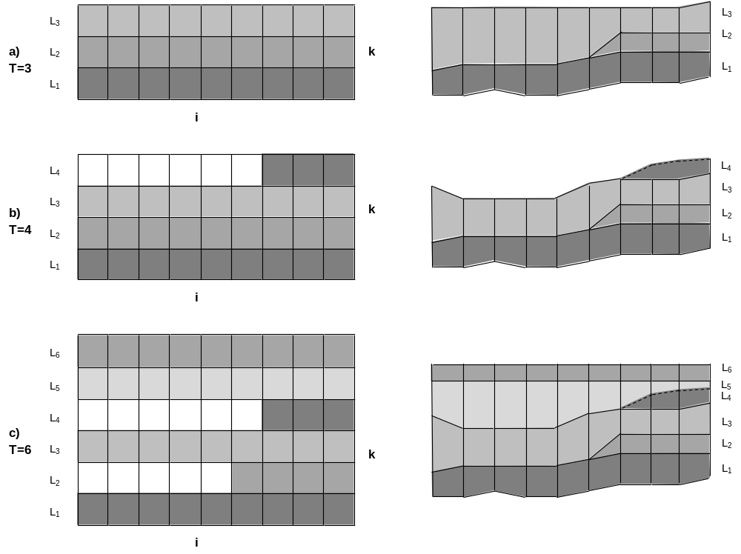
Figure 5 Cross section of Cauldron computational grid for zonal variables at three different time steps. Left: base space i-k plane; white grid cells have no defined property. Right: material properties mapped onto x-z cross section of subsurface geometry.
Figure 5 shows how formations of the developing subsurface structure are represented in the Cauldron computational grid. L₁ is the formation between T₀ and T₁, and so on. L₃ has first been deposited between T₂ and T₃ and then partially eroded between T₃ and T₄. Areas of non-deposition or erosion form discontinuities, and there are no material properties defined for them.

Data Volumes
A large present-day finite element mesh is approximately 500 by 500 by 70 elements, or about 16 million elements. According to Olivier Meuric, we would like to be able to handle meshes that are up to about 750 million elements in the long term. Note that the total volume of data goes as the square of (a fraction of) the number of vertical elements, since each element represents a time step, and there is one mesh per time step. This implies total data volumes of several terabytes, far greater than can fit in GPU or main memory on even a very large server. Most users will only view a fraction of this data, choosing a subset of properties relevant for their business case.
The highest data volume case involves flipping quickly through all available meshes for a given property, i.e. watching that property and its associated geometry change through time. The depth property must always be loaded to view data correctly positioned in space, and the desired property must be available for coloring the mesh. For the “large” case described above, this comes to 2 (properties) * 4 (bytes per element) * 500 (I) * 500 (J) * (½ * 70 * 71 = 70+69+68…) (Meshes) == ~5 gigabytes. For the long-term case this comes to dozens or hundreds of gigabytes.
This volume of data is just within the capacity of modern GPU card memory, suggesting that we should be able to animate between properties at reasonable rates. The total data may take a minute or more to load from disk. However if data sizes multiply by 10, we will be out of luck on a single server!
Because these data volumes will push the limits of our disk and GPU budgets, we must consider alternative approaches to maintain the performance users expect. During the evaluation phase of the project, we will prefer toolkits that make these approaches easier.
- Animate only slices of the data. If we restrict fast motion through time steps to only a few surfaces in the mesh, then we can cut the size of the problem by roughly a factor of I or K, i.e. by 50-500.
- Utilize out-of-core techniques. By paging data between faster GPU SRAM and slower main DRAM as it is needed, a graphics system can often still render at reasonable speeds. PCI-Express 3.0 can transfer data roughly at 15 GB/s, suggesting that if the data is available in main memory, we should be able to animate time steps.
- Depopulate the data. We can down-sample the data by a factor of 2 or 3 in each direction to reduce data volumes from a factor of 8 to 27. This can be acceptable for gross visualizations, or when zoomed out, or for data that is out of focus. Unfortunately it can involve the same amount of data traffic, or keeping multiple down-sampled copies of the data.
- Get more hardware. Using multiple machines at once to store and render the data could mean very rapid animation between meshes. In the CDIS system, 10-100 machines hold data live in memory and funnel it to 1 or more graphics machines for very rapid visualization. This approach involves no compromise on data volumes or visualization speeds. It has demonstrated the ability to visualize 10+ TB of data, though only a few dozen MB at a time.
We believe the first two approaches are the best to examine for NGBAs needs. The last approach is the most extravagant and should only be examined if the first two do not work.

Time-Independent Data Queries/Viewing Patterns
The solution should visualize results from all of the following queries. Assuming an instantaneous data service, we should evaluate how quickly these scenes can be drawn. Note that all of these patterns must be considered to function quickly through geologic time. That is, for any given query, one must imagine a slider that allows the current view to be changed to a previous time step, showing the same parts of the mesh – except those which did not exist in the past. This list should be evaluated because some toolkits may be able to evaluate these in the visualization module, rather than in the data module.
- Entire mesh. This is the default view, whereby one can quickly survey the entire project.
- Grid-aligned subset. One should be able to slice away parts of the mesh by imposing I, J, and K sub-ranges.
- Grid aligned 2D slice (constant I or J). Hiding the mesh, one should be able to create an arbitrary number of vertically-aligned slices along the natural grid-lines of the mesh, and roam them through space to examine the mesh.
- Horizon (constant K). As above, but with arbitrary horizons. This is a slightly different case because these surfaces will not be smooth.
- 1D extraction along a line (well). Showing data along a well path (a 1D line through 3D space), colored by one or more properties, with a lathe viewer.
- Arbitrary 2D extraction. The intersection of an arbitrary 2D surface should be colored or textured by properties found in the mesh. (Useful for visualizing properties along a horizon or against a salt-body or other intrusion.)
- Isosurface Extraction. The isosurface of a particular property should be quickly shown. (In common use, an iso-surface will be a 2D grid, but in the general case it may not be representable as a classic height field, that is for any XY position, there may be multiple Z values).

Time-Dependent queries
- 1D extraction through time (burial history). This data will not be visualized in 3 dimensions, but is more likely to be drawn in a charting package. It is included here for completeness.
- 2D extraction through time (Wheeler-like diagram).

Performance Expectations
- Time Roaming. 10fps. This operation is one of the most important, allowing users to roam through time at interactive speeds. Animations are relatively smooth at this frame rate.
- Property Change. 2fps. Switching between properties is common, but doesn’t require interactive speed.
- Space Roaming. 10fps. Moving slices through space is how 3D volumes are most easily visualized. This roaming should also be interactive.
- Camera Movement. 10fps+. Moving the camera should be smooth; theoretically it should be faster than roaming through time or space because no new data is needed, just new rendering.

Additional Rendering Primitives
Any rendering package chosen should have graphics primitives available for rendering the following entities in a similar fashion as nDI or Petrel.
- Faults
- Wells
- GIS Data
- Cross-Sections
- Salt/Magma?
- Vector fields for some migration/darcy data?

Web Viewing
JavaScript controls will need to be developed to allow the user to zoom, rotate, pan, etc., as well as provide interactive hit tests, annotations, and the like. With the CDIS application as an example, we can assume these have no technical risk and are easy to implement. There is no sense in writing them during our evaluation, however it is worth getting UX consensus on what the controls should look like.

Evaluation Phase
The evaluation of the above rendering can be informed by inspection of what is already possible in standard desktop 3D applications, like Petrel or nDI. We know that typical numbers of wells, faults, and horizons are straightforward to render with a mature framework. The primary question is whether the potentially large meshes can be updated and rendered at interactive speeds.
Note that the latency & bandwidth of random access to the Cauldron mesh data in the HPC environment is under investigation separately on the TACC Stampede cluster in Q4 2013, so does not belong properly to this evaluation. We can assume that the data we need is already in RAM.
The proposed libraries for 4D web-based rendering are
- OpenInventor MeshViz. Already licensed by Shell, OpenInventor is used in nDI and Petrel extensively, has strong commercial support and excellent performance. It is the first alternative to consider. (WebViz may also provide the encoding/decoding component to view this data in a browser.)
- ParaView. Open Source visualization framework used widely in academia. Less familiar within Shell.
- HueSpace. Commercial subsurface programing framework, focused on the desktop. Also less familiar.
- nVidia indeX. Used by the CDIS team, Shell already owns it, it is capable of massively parallel rendering on staggeringly large datasets, but the implementation is quite primitive, with many important graphics missing. Their mesh capabilities are not complete. Therefore we propose investigating this only if the other alternatives fail.
One developer can carry out this evaluation by writing a console application using the OpenInventor MeshViz framework.
The proposed steps are as follows. Estimates are low-end cases, possible time could be 2 times this.
- Learn. (2 week) Install and compile sample applications, getting familiarity with the product. (Many Shell resources are available or help.)
- Draw a Mesh. (2 weeks) Loading a large mesh in its entirety, rendering it with simple property colorings, and measuring frame rates as a camera is moved. If the data is available in RAM (e.g. pre-loading temperature and geometry grids for all timesteps) how quickly can one render frames at 2560x1440, 1920x1080 and 1024x768 with each mesh? 100ms is the maximum time.
- Change a Mesh. (1 week) Assuming all raw Cauldron data is in RAM, can we animate a temperature mesh back in time at 10fps?
- Change a Property. (1 week) Assuming all raw Cauldron data is in RAM, can we switch from one property to another and re-render in 500ms?
- Roam a slice. (2 weeks) How quickly can we roam an I-slice through the mesh? Goal is greater than 10fps.
- Evaluate web connection. (1 week, optional) Write a small web page that connects via the web encoding/decoding framework and do a subjective evaluation of compression, frame rate, etc. (WebViz). Note: this step of the evaluation is not critical: we know that the nVidia indeX component can already do this work at adequate frame rates and resolutions. If WebViz doesn’t work well, we can fall back to indeX.
(note: slices & isosurfaces should be timed too, but since these are built into the framework, it’s unclear how we’d improve on them implementing them ourselves.)

Implementation Phase
Implementation of 4D viewing must be driven by NGBA requirements, to be determined December 2013.

500x500x75 cells, taken from a recent sanitized Gulf of Mexico model.
Derived from the following sources: http://www.verizonenterprise.com/about/network/latency/ http://www.igvita.com/2012/07/19/latency-the-new-web-performance-bottleneck/ http://www.dotcom-monitor.com/WebTools/network_latency.aspx http://wiki.lustre.org/index.php/FAQ_-_Object_Servers_and_I/O_Throughput
Actually, you can buy servers with 1TB of RAM, but these are a little harder to come by and most users wouldn’t look at all the data anyway.

